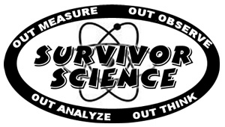
Reward Challenge
Teacher Trivia

How much do you know about your teacher?

1. What is your teacher’s first name? ____________________

2. What are the first names of her husband and son? _____________ and _____________

3. Where did she go to high school? ____________________

4. Where did she go to college? _____________________ When did she graduate? ______

5. What are your teacher’s favorite colors? _____________ and _____________

6. What is your teacher’s favorite type of animal? __________________________

7. What is your teacher’s favorite place to visit? __________________________

8. What is her favorite candy? Need the name of a specific brand of candy! ___________

9. What was your teacher’s favorite subject in school? ___________

10. In what month is your teacher’s birthday? ________________

11. What is your teacher’s favorite TV show? _____________________

12. What is her favorite hobby? ____________________

Tie Breaker:
What year was your teacher born? _______________________

Total Correct: ________

