
GeoTroopers

It’s time to test your science & navigation skills!

Team Members: _______________________________________________ Team Color: _________
Use the Challenge Cards to help you find the information needed to complete this assignment.
First – Calculate the waypoint using the information given and then use the GPS unit to find the location.
Second – Complete the task listed on the Challenge Card or hidden in the microcache (film canister).
All microcaches must be left EXACTLY as you found them – paper inside and in same spot!
Challenge # _____

A # _____ -_________________________
B # _____ -_________________________
C # _____ -_________________________
D # _____ -_________________________

Challenge # _____

A # _____ -_________________________
B # _____ -_________________________
C # _____ -_________________________
D # _____ -_________________________

Challenge # _____

A # _____ -_________________________
B # _____ -_________________________
C # _____ -_________________________
D # _____ -_________________________

Challenge # _____

A # _____ -_________________________
B # _____ -_________________________
C # _____ -_________________________
D # _____ -_________________________

Challenge # _____

A # _____ -_________________________
B # _____ -_________________________
C # _____ -_________________________
D # _____ -_________________________

Challenge # _____

A # _____ -_________________________
B # _____ -_________________________
C # _____ -_________________________
D # _____ -_________________________

Tie Breaker: Choose a number between 1 and 100 - _________

Challenge #2

#2A
Waypoint:
# of letters in the name of element Si x 3

Task:
Use the Tree ID Guide to identify this tree.

#2B
Waypoint:
# of letters in the name of the animal group that contains crabs, lobsters, and shrimp (plural form)

Task:
What type of plant is this? Hint: Monarchs need this plant!

#2D
Waypoint:
# of valence electrons in an atom of Boron

Task:
Find the microcache at this location and answer the question inside. Replace it EXACTLY where you found it!

#2C
Waypoint:
# of extra day(s) in a leap year

Task:
Find the microcache at this location and use the Insect ID book to help you identify the order to which the insect belongs. Replace it EXACTLY where you found it!

Challenge #1

#1A
Waypoint:
# of months in a year + 4

Task:
Use the Tree ID Guide to identify this tree.

#1B
Waypoint:
Atomic Mass of Nitrogen (rounded)

Task:
What type of plant is this? Hint: Its name might make you think of a feline.

#1D
Waypoint:
# of protons in Potassium

Task:
Find the microcache at this location and answer the question inside. Replace it EXACTLY where you found it!

#1C
Waypoint:
# of legs on an insect

Task:
Find the microcache at this location and use the Insect ID book to help you identify the order to which the insect belongs. Replace it EXACTLY where you found it!

Challenge #4

#4A
Waypoint:
# of neutrons in an atom of Be

Task:
Use the Tree ID Guide to identify this tree.

#4B
Waypoint:
# of letters in the name of the group that contains frogs and toads (plural form)

Task:
What type of plant is this? Hint: This plant is used for perfumes and is also the name for a light-purple color.

#4D
Waypoint:
# of letters in the term for animals that eat other animals – 3 (plural form)

Task:
Find the microcache at this location and answer the question inside. Replace it EXACTLY where you found it!

#4C
Waypoint:
# of electrons in an atom of Calcium

Task:
Find the microcache at this location and use the Insect ID book to help you identify the order to which the insect belongs. Replace it EXACTLY where you found it!

Challenge #3

#3A
Waypoint:
# of letters in the animal group that contains spiders + 8 (plural form)

Task:
Use the Tree ID Guide to identify this tree.

#3B
Waypoint:
# of letters in the name of a square yellow cartoon character that lives in Bikini Bottom

Task:
What type of plant is this? Hint: It might be used in chewing gum and tea.

#3D
Waypoint:
# of electrons in an atom of Titanium

Task:
Find the microcache at this location and answer the question inside. Replace it EXACTLY where you found it!

#3C
Waypoint:
The “unlucky” number – Friday the __^{th}

Task:
Find the microcache at this location and use the Insect ID book to help you identify the order to which the insect belongs. Replace it EXACTLY where you found it!

Challenge #6

#6A
Waypoint:
# of electrons in an atom of Argon

Task:
Use the Tree ID Guide to identify this tree.

#6B
Waypoint:
# of months in a leap year

Task:
What type of plant is this? Hint: The name might refer to a girl with dark eyes.

#6D
Waypoint:
Number of protons in an atom of Na + Number of protons in an atom of Mg

Task:
Find the microcache at this location and answer the question inside. Replace it EXACTLY where you found it!

#6C
Waypoint:
Number of valence electrons in an atom of Mg

Task:
Find the microcache at this location and use the Insect ID book to help you identify the order to which the insect belongs. Replace it EXACTLY where you found it!

Challenge #5

#5A
Waypoint:
# of legs on an arachnid

Task:
Use the Tree ID Guide to identify this tree.

#5B
Waypoint:
# of letters in the name of element Sn x 5

Task:
What type of plant is this? Hint: It is the same name as Donald Duck’s girlfriend.

#5D
Waypoint:
Number of energy levels in Potassium.

Task:
Find the microcache at this location and answer the question inside. Replace it EXACTLY where you found it!

#5C
Waypoint:
# of protons in an atom of Manganese - 1

Task:
Find the microcache at this location and use the Insect ID book to help you identify the order to which the insect belongs. Replace it EXACTLY where you found it!

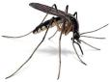
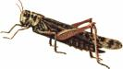
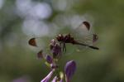
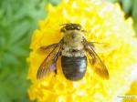
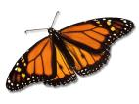
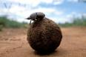
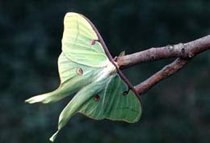
#1D – What type of consumer eats insects? An example is a frog.
#2D – What provides all the energy in a food web? Hint: It is a star!
#3D – What type of organism supplies all the food for an ecosystem? Choose one: Producer, Consumer, or Decomposer

#4D – What type of consumer eats plankton (the microscopic organisms that live in water)?
#5D – Give an example of a biotic factor that is found in the schoolyard habitat.
#6D – How would carnivores, omnivores, and herbivores be classified? Choose one: Producer, Consumer, or Decomposer
#7D – How are molds, fungi, and bacteria classified? Choose one: Producer, Consumer, or Decomposer

3C
4C
5C
1C
2C
Dung
7C
Challenge #7
#7A
Waypoint:
If an organism has a total of 40 chromosomes, how many would each sex cell have?

Task:
How would you classify this tree?
Choose one: Deciduous or Conifer

#7B
Waypoint:
# of neutrons in an atom of Ti

Task:
Unscramble the letters to figure out the name of this plant: H LOLY HCOK

#7D
Waypoint:
# of electrons in an atom of Fe – 1

Task:
Find the microcache at this location and answer the question inside. Replace it EXACTLY where you found it!
#7C
Waypoint:
# of days in February (not a leap year) - 1

Task:
Find the microcache at this location and use the Insect ID book to help you identify the order to which the insect belongs. Replace it EXACTLY where you found it!
Print the questions and pictures below. Place each one in a film canister to create a microcache and hide at the specified waypoints.

Answer Key:

Challenge 1
A – Waypoint = 16, Tree = Dogwood
B – Waypoint = 14, Plant = Cattails
C – Waypoint = 6, Insect = Lepidoptera
D – Waypoint = 19, Plant = Insectivore

Challenge 2
A – Waypoint = 21, Tree = Blue Spruce
B – Waypoint = 11, Plant = Milkweed
C – Waypoint = 1, Insect = Coleoptera
D – Waypoint = 3, Plant = Sun

Challenge 3
A – Waypoint = 17, Tree = Pin Oak
B – Waypoint = 9, Plant = Mint
C – Waypoint = 13, Insect = Diptera
D – Waypoint = 22, Plant = Producer

Challenge 4
A – Waypoint = 5, Tree = Sweet Gum
B – Waypoint = 10, Plant = Lavender
C – Waypoint = 20, Insect = Orthoptera
D – Waypoint = 7, Plant = Planktivore

Challenge 5
A – Waypoint = 8, Tree = White Oak
B – Waypoint = 15, Plant = Daisy
C – Waypoint = 24, Insect = Odonata
D – Waypoint = 4, Plant = Any living thing

Challenge 6
A – Waypoint = 18, Tree = Elm
B – Waypoint = 12, Plant = Black-eyed Susan
C – Waypoint = 2, Insect = Hymenoptera
D – Waypoint = 23, Plant = Consumer

Challenge 7
A – Waypoint = 20, Tree = Conifer
B – Waypoint = 26, Plant = Holly Hock
C – Waypoint = 27, Insect = Lepidoptera
D – Waypoint = 25, Plant = Decomposer

Don’t have GPS units? Use colored flags with numbers on them or another type of marker that the kids can look for in the schoolyard. You might also provide a map of the schoolyard with the numbers listed at each location.

Each tribe received a tree identification book, a Golden Guide: Insects book, a copy of a periodic table, and copies of the Ecology and Animal World textbooks. I give tribes 10 to 15 minutes on the day before this challenge to review and record notes that they may use on the challenge. You can also provide the “Things to Know” handout on the next page.

Things To Know ...

Food Chain – Shows the relationships of animals in an ecosystem.

Food Web – A collection of all the food chains in an ecosystem

Biotic – The living things in an ecosystem; plants and animals

Abiotic – The nonliving things in an ecosystem; air, water, soil, rocks, etc.
Ecology Review

Producers – Source of all the food in an ecosystem

Consumer – Organisms that cannot produce their own food; carnivores, herbivores, omnivores, insectivores, and plantivores

Decomposers – Organisms that break down dead plants and animals; molds, fungi, and bacteria

Atomic Number - # of protons or electrons
Symbol & Name
Atomic Mass - # of
protons + neutrons
1
H
Hydrogen
1.00794
Types of Trees

Deciduous – Trees that lose their leaves each fall

Coniferous – Trees that produce cones and needles with some needles staying on the tree all year long

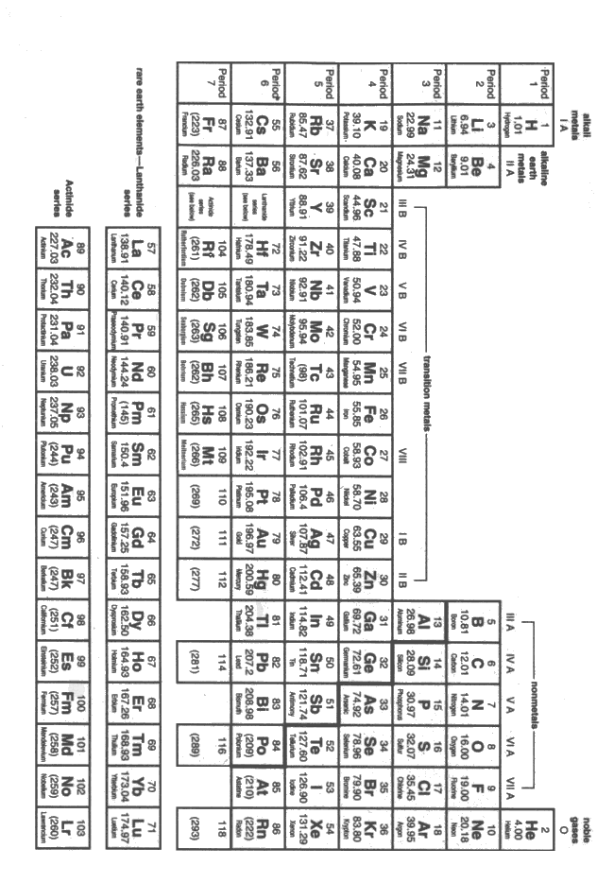
# of Valence Electrons = Family (column)
# of Energy Levels = Period (row)

6C

